# Executive Summary

The 2022 Communications Survey was a collaboration between representatives of the BCA, The Bugle and burtonvillage.org. The survey aimed to gather residents’ views on how we as a community share information across the village.

This report explains the background and methodology of the survey, along with the results and analysis. The report is intended as a tool in the improvement of our village communications strategy.

#### Email

The BCA Secretary (currently Chris Bennett) is the hub for village-wide emails. Almost 80% of residents are satisfied with the volume of emails. Some participants expressed concern over the burden placed on one person (Chris).

Residents were keen to avoid receiving duplicated information, such as that relating to the Church and BCA. Some email content caused varying levels of offence.

#### The Website

Duplicated information is also an issue for website users. Not every participant finds the website easy to navigate. Several residents suggested making more use of the website, some making specific requests, such as for a page of resident-recommended tradespeople.

#### The Bugle

For offline residents, the newsletter is the main form of organised village communication received. While this is printed and delivered free of charge, the cost is borne by one resident. Potential alternatives to the current service failed to appeal. However, a resident is willing to share the printing and delivering responsibilities.

Other participants commented on The Bugle’s format.

#### Further Comments

Participants suggested additional platforms, including WhatsApp, while noting the additional responsibility of moderating and managing such platforms.

Many asked for better integration between the different platforms, thereby reducing duplication.

Based on these findings, the Comms Team have made the following recommendations:

* Re-visit the Charities Commission re. funding the Bugle
* Those responsible for each platform to work together to find ways of minimising duplication
* Consider setting up WhatsApp group(s), for instance, in respect of for sale items and recommendations for tradespeople
* BCA to consider providing additional resource to support Chris Bennett with email distribution, within the confines of data protection
* Consider a drive to familiarise residents in need with the website
* The Bugle team to contact the resident willing to print and deliver copies
* Time the launch of any future surveys to avoid running simultaneously, or back-to-back.

Table of Contents

Executive Summary 1

Background 3

Methodology 3

Results and Analysis 4

Participation 4

Email 4

Website 7

The Bugle 8

Final Comments 9

Additional Platform(s) 9

Improving our online skills 9

Would you be willing to contribute to village communications? 9

How can we improve village communications? 10

# Background

Burton uses a variety of platforms, including email, [newsletter](https://burtonvillage.org/the-bugle/), [website](https://burtonvillage.org/) (burtonvillage.org) and [Facebook](https://www.facebook.com/BurtonVillage/) to share information of relevance to its residents.

In April 2022, representatives of the three main disseminators of information, namely, The Bugle, the [website](https://burtonvillage.org/), and the BCA, came together as an informal communications team (the ‘Comms Team’) to review how and what is communicated. The discussion covered village-wide communication in terms of:

* **Accessibility.** Do residents know where to find information?
* **Inclusivity.** How do we ensure all residents receive the information they want?
* **Efficiency.** Are we sharing the right information, within an appropriate timeframe, without avoidable duplication?
* **Resource sustainability.** How can we balance the burden of information dissemination? Where can we minimise the environmental and economic cost?
* **Mode.** Could we be smarter in how we use our current platforms? Are we using the right platforms?

On 25 May 2022, a survey was launched to gather residents’ views on how we as a community share information across the village.

# Methodology

The Comms Team’s survey aimed to address identified issues with each platform. A draft was reviewed by trustees of the BCA. The online version of the survey (using Crowd Signal freeware) was piloted before launch.

At the request of the BCA, the launch of the survey was delayed in favour of the BCA’s AGM questionnaire. The communications survey was then released one week after the AGM survey had launched.

**Survey Distribution**

156 email addresses

9 offline households

The survey was distributed to Burton residents mainly via emailed link to the website, with a small number of hard copies hand delivered to residents without access to the internet. The survey remained open for a week.

# Results and Analysis

The survey was divided into four parts, the first two of relevance to online participants only, the third specifically for offline residents, and the final section was open to all. In reporting the results, percentages reflect the opinion of the relevant subgroup. For instance, data for the email section are reported as a percentage of the 156 email addresses.

A selection of respondents’ comments accompanies the data provided, presented here to summarise the consensus.

## Participation

Only 18% of online residents participated, compared with 44% of offline residents. A total of 19% across Burton.

**Participant Numbers**

**28 online**

**4 offline**

**32 overall**

This may be an indicator of survey fatigue among participants, owing to this being the second survey in the same number of weeks. Alternatively, the low response rate may signify that Burton residents are content with village-wide communication as it stands.

## Email

Residents were asked what they thought of the amount of village-wide emails circulated.

Some 79% of online respondents reported the amount is about right, with 21% reporting they found it too much. No one reported it is not enough.

Presented with a list of common email subjects and asked to tick all they are happy to receive by email, 96% of online residents wanted to receive emails about crime incidents. Events (93%) and public services (82%) also scored highly. Of least interest to residents were emails about nuisances (68%), the BCA (68%) and Church matters (54%).

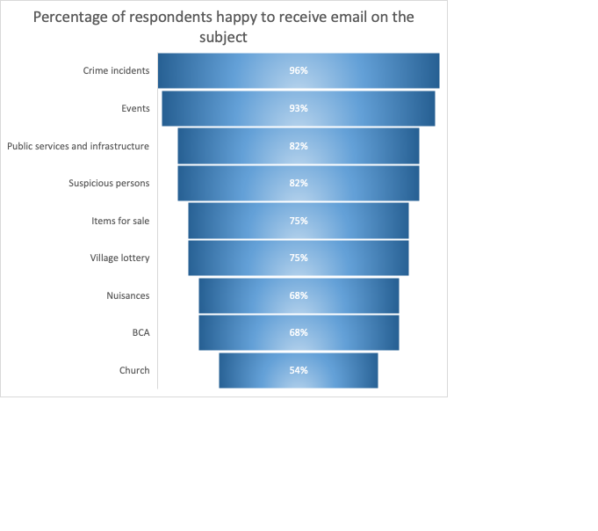

When asked which information they do not want to receive by email, several residents commented that some information was available elsewhere, and email only duplicated it. This included, church services, lottery BCA & items for sale.

Others raised the content of some emails received.

‘While dog poo is a nuisance, we don't need photos of it arriving in our inbox.’

Just under half (43%) of residents were not aware the village has a Facebook Marketplace page called [For Sale, Free or Wanted in Burton In Wiltshire & Surrounding Area](https://www.facebook.com/groups/591508791472162/), to buy and sell items.

This platform could be used as an alternative to the for-sale items which are circulated by email, thus reducing the volume of emails received. However, one respondent added:

‘I don’t use Facebook and would not use it to either sell or purchase items. I am, however happy to receive emails about buying and selling within the village as I feel a local item would be genuine. From a security point of view I would not like strangers coming to my home and if I bought something from someone within the village I would probably know, or know of them.’

Commenting on the email service overall, many praised the service, and head postmaster Chris Bennett specifically, while noting the onus fell on one person.

‘I like the emails, but I do wonder how poor Chris feels about having to field them all...’

‘The approach puts the burden on one person, people need to take more individual responsibility and get involved more’

‘the email works very well. However, some of Chris's emails go straight to junk mail. Also, when Chris is on holiday, there is no stand-in.’

‘...Email is great for important instant communication...’

Others suggested the website be made the prime source of information:

‘Why can the we[b]site not be the primary method of dissemination of information’

‘Can’t information be placed on the website. As that sends an email out as well.’

A suggestion was made to aid email recipients filter information relevant to them:

‘Perhaps use some kind of signal in the subject header? Either a traffic signal of Important or Low Importance, or a category, eg. EVENT, PSB...’

**Chris Bennett replies:**

**I have discussed the survey (email) feedback with the website administrator and Bugle editorial team. We agreed there are opportunities to reduce email volume when it is available from other sources. More careful use of email subject heading may assist with recipient filtering. Filtering of urgent/less urgent content is currently done, although more could be done to signpost some requests to other sources.**

## Website

The website acts as repository for village-related information, including its history, environment, church, the BCA, and various clubs and societies. It also provides a calendar of events.

59% of online respondents subscribe to the website. 19% are either not interested or chose not to resubscribe when the website changed address.

When asked to comment on the website, residents raised the following issues:

‘I am currently getting some notifications about website blogs twice which is quite irritating. I also wish there was a way to not get notifications about things which are in the Bugle, as I prefer the newsletter to the website blogs. I may end up unsubscribing to the blogs as they come quite often, and are often repeats. I would prefer a weekly update of new material than lots of emails.’

‘...I haven’t always found it easy to navigate...’

Respondents considered the website’s potential:

‘There are often messages asking for recommended local tradespeople. Could there be a section on the website for this?’[1]

Positive comments were also received:

‘I really like the website... I enjoy the blogs that are posted and feel it is a really useful asset to village communications.’

**The website administrator replies:**

**We are collaborating with The Bugle and the email service to reduce duplication. It goes without saying, we want users of the site to find the information they are looking for easily. While the header menu follows standard practice, we will be trying out different menu titles over the coming months, which we hope will be more descriptive of the information found beneath the title.**

## The Bugle

Print versions of The Bugle are privately funded by one resident and hand delivered. The survey sought views on lower-cost, environmentally friendly options, including making use of the village notice board, a verbal update at the lunch club, or a public copy held in an accessible designated place. This question was aimed primarily at offline residents.

Offline respondents were not interested in any of the alternatives to the hand-delivered service. One commented that they were kept up to date by neighbours.

Of online respondents, 4% would like a public copy of The Bugle, plus linked articles, made available in the Church or other designated point.

The same were willing to help print and deliver the newsletter.

Participants also commented on The Bugle’s format:

‘Improve the appearance of The Bugle. A pdf would help readers navigate around what has become a fairly chunky read.’

‘The printed ‘Bugle’ does not usually show web addresses (The April Edition was a welcome exception). An explicit web address on the back page would be welcome.’

**The Bugle editorial team replies:**

**We welcome the survey feedback and confirm we are committed to ensuring the newsletter is accessible to all.**

**Use of MailChimp software will be subject to periodic review, based on the availability of alternative no-cost software applications. Unfortunately, a pdf version direct from the website does not export across in a clear/concise format.**

## Final Comments

### Additional Platform(s)

When asked whether residents would be interested in a village-wide WhatsApp group, or similar, just over a third (36%) responded positively.

One resident suggested:

‘I think a number of topic specific What'sApp groups would help target / focus information for interested parties.’

However, one respondent commented:

‘Not whatsapp because of the security issues, but signal would be good.’

In addition to WhatsApp and Signal, other platforms suggested by residents include YouTube, Zoom, Teams, Facebook and:

‘A more accessible notice board (maybe something near the tea shop).’

One resident added:

‘I think there are sufficient platforms already but perhaps a more integrated approach would streamline things to avoid repetition. However I appreciate that many people may only access particular platforms to the exclusion of others.’

### Improving our online skills

A small selection of free bite-sized training was offered to assist residents who either wish to gain confidence in using the internet, or who want to develop their website publishing skills. Between 7-11% of residents who replied were interested in each training session offered.

These residents will be contacted shortly.

### Would you be willing to contribute to village communications?

The Bugle and the website are always keen to include the views and interests of Burton residents. For those residents who reported they are willing to write the occasional article, and for anyone else with ideas for articles, please do get in touch.

* For the website, articles should be no more than 350 words, please provide at least one good quality image. Contact: [webadmin@burtonvillage.org](mailto:webadmin@burtonvillage.org)
* For The Bugle, contact: [bugle@burtonvillage.org](mailto:bugle@burtonvillage.org)

A couple of online participants are willing to provide training or mentoring in desktop publishing software to improve The Bugle’s appearance and to help readers find their way around it more easily.

These residents will be contacted in due course.

### How can we improve village communications?

This question drew many responses, some of which have been included under the most relevant section in this report.

Comments ranged from broad statements such as:

‘Ensure accessibility for everyone’

‘Make it engaging and with a purpose... Dont let it become wallpaper...’

Through to specifics.

On better integration/reducing duplication:

‘Direct more towards the website by linking it via the Bugle.’

‘less repetition, though I know that some will not be accessing all 3 methods most with digital communications will.’

‘Don’t double up on emails, websites and bugle saying the same thing.’

‘Be a little more selective over what is sent out on email. Reduce duplication.’

‘Simplicity using website and Bugle as a summary each month‘

On moderating social media:

‘As it stands today, multiple sources of communication seem to work and ensure that no one is excluded. Although it may be confusing to new residents that we have two websites for example. Instagram and Twitter accounts could be added but the more presence the village has in social media the more it has to be moderated and managed.’

On particular interests:

‘Keep us updated on flora and fauna around the village and wildlife spotting with images’

Village communications also received praise:

‘I think you do a fantastic job as it is. Well done to all.’

‘I think it is already pretty good.’

‘It's so good I can't think of a sensible suggestion that could make it better...’

‘I think it's pretty good!’

1. The website does have a Local Services, Enterprises and Trades section <https://burtonvillage.org/local-services-enterprises-trades/>, with Trades listed [here](https://burtonvillage.org/sample-page-2/local-trades/).